DAA LAB — EXPERIMENTAL ANALYSIS
Question: Perform experimental analysis using different input sizes and input conditions (sorted, reverse-sorted, and random data). Record execution time and memory usage.
Code
import time,tracemalloc,random
from sorting_algorithms import bubble_sort,selection_sort,insertion_sort,merge_sort,quick_sort,heap_sort
alg={"Bubble Sort":bubble_sort,"Selection Sort":selection_sort,"Insertion Sort":insertion_sort,"Merge Sort":merge_sort,"Quick Sort":quick_sort,"Heap Sort":heap_sort}
sizes=[100,500,1000]
random.seed(42)
print("Algorithm,Size,Condition,Time_ms,Peak_Memory_KB")
for n in sizes:
data={"Sorted":list(range(n)),"Reverse-Sorted":list(range(n,0,-1)),"Random":[random.randint(0,100000) for _ in range(n)]}
for name,f in alg.items():
for cond,a in data.items():
ts=[]; ms=[]
for _ in range(3):
tracemalloc.start(); s=time.perf_counter(); f(a); ts.append((time.perf_counter()-s)*1000)
_,peak=tracemalloc.get_traced_memory(); tracemalloc.stop(); ms.append(peak/1024)
print(f"{name},{n},{cond},{sum(ts)/3:.4f},{max(ms):.2f}")
Display Results
The program prints Input Size, Condition, Time (ms), and Peak Memory (KB) for every implemented sorting algorithm.

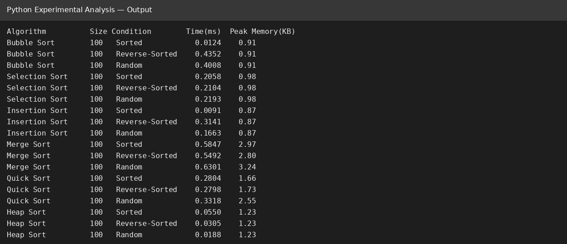
Simple explanation
input_sizes → different values of n
Sorted → already sorted input
Reverse-Sorted → descending input
Random → randomly generated input
time.perf_counter() → measures execution time
tracemalloc → measures Python memory usage
tracemalloc.get_traced_memory() → returns current and peak traced memory
Memory
Peak memory is converted to KB by dividing the value returned by tracemalloc by 1024.
GitHub Link
____________________________________________
Paste the GitHub repository/file URL after uploading the Python code.

